|  |
| --- |
| **Karan Arora** **R.L. Chemistry Classes M: 99968-68554**  **Class : XII**  **“SOLUTION”** |

**Competition Assignment – 1**

1. Which of the following units is useful in relative concentration of solution with its vapour pressure?

|  |  |  |  |
| --- | --- | --- | --- |
| a) mole fraction | b) parts per million | c) mass percentage | d) molality |

1. On dissolving sugar in water at room temperature, solution feels cool to touch. Under which of the following cases dissolution of sugar will be most rapid?

|  |  |
| --- | --- |
| a) Sugar crystals in cold water | b) Sugar crystals in hot water |
| c) Powdered sugar in cold water | d) Powdered sugar in hot water |

1. Add equilibrium the rate of dissolution of a solid solute in a volatile liquid solvent is __________.

|  |  |
| --- | --- |
| a) Less than the rate of crystallization | b) Greater than the rate of crystallization |
| c) Equal than the rate of crystallization | d) zero |

1. A beaker contain a solution of substance ‘A”. Precipitation of substance ‘A’ takes place when small amount of ‘A’ is added to the solution. The solution is _________.

|  |  |  |  |
| --- | --- | --- | --- |
| a) saturated | b) supersaturated | c) unsaturated | d) concentrated. |

1. Maximum amount of a solid solute that can be dissolved in a specified amount of a given liquid solvent does not depend upon __________.

|  |  |  |  |
| --- | --- | --- | --- |
| a) Temperature | b) nature of solute | c) pressure | d) nature of solvent |

1. Low concentration of oxygen in the blood and tissues of people living at high altitude is done due to ___________.
2. Low temperature.
3. Low atmospheric pressure.
4. High atmospheric pressure.
5. Both low temperature and high atmosphere pressure
6. Considering the formation, breaking and strength of hydrogen bond. Predicts which of the following mixture will show a positive deviation from Raoult’s Law?

|  |  |
| --- | --- |
| a) Methanol and acetone | b) Chloroform and acetone |
| c) Nitric acid and water | d) Phenol and aniline. |

1. Colligative properties depends on ___________.
2. The nature of the solute particles dissolved in the solution.
3. The number of solute particles in solution.
4. The physical properties of the solute particle dissolved in solution.
5. The nature of solvent particles.

SOLUTION Page No. 1

1. Which of the following aqueous solution should have the highest boiling point?

|  |  |  |  |
| --- | --- | --- | --- |
| a) 1.0 M NaOH | b) 10 M Na2SO4 | c) 1.0 M NH4NO3 | d) 1.0 M KNO3 |

1. The unit of ebullioscopic constant is________________.

|  |  |
| --- | --- |
| a) K kg mol – 1 or K (molality) – 1 | b) mol kg K – 1 or K – 1 (molality) |
| c) kg mol – 1 K – 1 or K – 1 (molality) – 1 | d) K mol kg – 1 or K (molality) |

1. In comparison to a 0.01 M solution of glucose, the depression in freezing point of a 0.01 M MgCl2 solution is:

|  |  |  |  |
| --- | --- | --- | --- |
| a) the same | b) about twice | c) about 3 times | d) about 6 times |

1. An unripe mango placed in a concentrated sole solution to prepare pickle, shrivels because of:

|  |  |
| --- | --- |
| a) It gains water due to osmosis | b) It loses water due to reverse osmosis |
| c) It gains water due to reverse osmosis | d) It loses water due to osmosis |

1. At a given temperature, osmotic pressure of a concentrated solution of a substance ________.
2. Is higher than that at a dilute solution.
3. Is lower than that of a dilute solution.
4. Is same as that of a dilute solution.
5. Cannot be compared with osmotic pressure of dilute solution.
6. Which of the following statements is false?
7. Two different solutions of Sucrose of same molality prepared in different solvents will have the same depression in freezing point.
8. The osmotic pressure of a solution is given by the equation $π$ = CRT (where C is the molarity of the solution).
9. Decreasing order of osmotic pressure for 0.01 M Aqueous solution of Barium Chloride, potassium chloride, acetic acid and sucrose is : BaCl2 > KCl > Ch3COOH > sucrose.
10. According to Raoult’s law the vapour pressure exerted by a volatile component of a solution is directly proportional to its mole fraction in the solution.
11. The value of van’t Hoff factors for KCl , NaCl and K2SO4, respectively are :

|  |  |  |  |
| --- | --- | --- | --- |
| a) 2 , 2 and 2 | b) 2 ,2 and 3 | c) 1 , 1 and 2 | d) 1 , 1 and 1 |

1. Which of the following statements is false?
2. Units of atmospheric pressure and osmotic pressure are the same.
3. In reverse osmosis, solvent molecules move through a semi permeable membrane from a region of lower concentration of solute to a region of higher concentration.
4. The value of molar depression constant depends on nature of solvent.
5. Relative lowering of vapour pressure is a dimensionless quantity.
6. Value of Henry’s constant KH is _______.

|  |  |
| --- | --- |
| a) Increases with increase in temperature | b) Decreases with increase in temperature |
| c) Remains constant | d) First increases, then decreases |

1. Value of Henry’s constant KH is _______.

|  |  |
| --- | --- |
| a) Greater for gases with higher solubility | b) Greater for gases with lower solubility |
| c) constant for all gases | d) Not related to the solubility of gases |

1. We have three aqueous solutions of NaCl labelled as ‘A’, ‘B’ and ‘C’ with concentration 0.1 M, 0.01 M and 0.001 M respectively. The value of van’t Hoff factor for these solutions will be in the order_____________.

|  |  |  |  |
| --- | --- | --- | --- |
| a) iA < iB < iC | b) iA > iB > iC | c) iA = iB = iC | d) iA < iB > iC |

SOLUTION Page No. 2

1. On the basis of information given below mark the correct option:

Information:

1. In bromoethane and chloroethane mixture intramolecular interaction of A-A and B-B type are nearly same as A-B type interactions.
2. In ethanol and acetone mixture A-A and B-B type intermolecular interaction are stronger than A-B type interactions.
3. In chloroform and acetone mixture A-A and B-B type intermolecular interactions are weaker than A-B type interactions.
4. Solution (B) and (C) will follow Raoult’s law.
5. Solution (A) will follow Raoult’s law.
6. Solution (B) will show negative deviation from Raoult’s law.
7. Solution (C) will show positive deviation from Raoult’s law.
8. Two beakers of capacity 500 ml were taken. One of these beaker labelled as “A” was filled with 400 ml water whereas the beaker labelled “B” was filled with 400 ml of 2M solution of NaCl. At the same temperature both the beaker were placed in close containers of same material and same capacity as shown in the figure:

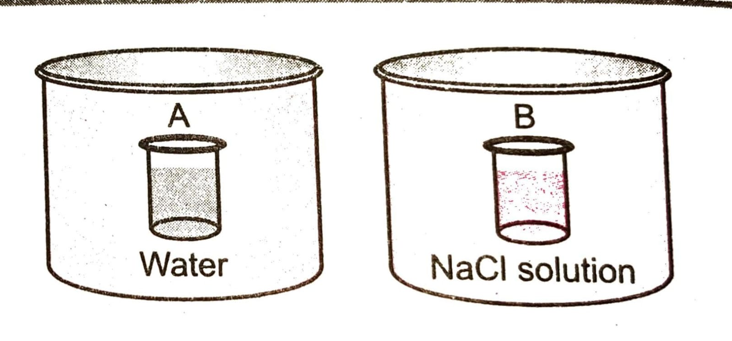

At a given temperature which of the following statement is correct about the vapour pressure of pure water and that of NaCl solution.

1. Vapour pressure in container (A) is more than in container (B).
2. Vapour pressure in container (A) is less than in container (B).
3. Vapour pressure is equal in both containers.
4. Vapour pressure in container (B) is twice the Vapour pressure in container (A).
5. If two liquid A and B form minimum boiling azeotropes at some specific composition, then _________:
6. A-B interactions are stronger than those between A-A and B-B.
7. Vapour pressure of solution increases because more number of molecules of liquids A and B can escape from the solution.
8. Vapour pressure of solution decreases because less number of molecules of only one of the liquids escape from the solution.
9. A-B interactions are weaker than those between A-A and B-B
10. 4 L of 0.02 M aqueous solution of NaCl was diluted by adding one litre of water. The molarity of the resultant solution is___________.

|  |  |  |  |
| --- | --- | --- | --- |
| a) 0.004 | b) 0.008 | c) 0.012 | d) 0.016 |

SOLUTION Page No. 3

1. On the basis of information given below mark the correct option:

Information: On adding acetone to methanol some of the hydrogen bonds between methanol molecules break.

1. At specific composition methanol-acetone mixture will form minimum boiling azeotropes and will show positive deviation from Raoult’s law.
2. At specific composition methanol-acetone mixture will form maximum boiling azeotropes and will show positive deviation from Raoult’s law.
3. At specific composition methanol-acetone mixture will form minimum boiling azeotropes and will show negative deviation from Raoult’s law.
4. At specific composition methanol-acetone mixture will form maximum boiling azeotropes and will show negative deviation from Raoult’s law.
5. KH value for Ar(g) , CO2 (g), HCHO (g) and CH4 (g) are 40.39 , 1.67 , 1.83 x 10 – 5 and 0.413 respectively. Arrange these gases in the order of their increasing solubility.

|  |  |
| --- | --- |
| a) HCHO < CH4 < CO2 < Ar | b) HCHO < CO2 < CH4 < Ar |
| c) Ar < CO2 < CH4 < HCHO | d) Ar < CH4 < CO2 < HCHO |

1. Which of the following is dependent on temperature?

|  |  |  |  |
| --- | --- | --- | --- |
| a) Molality | b) Molarity | c) Mole fraction | d) Weight percentage |

1. A 5.2 molal aqueous solution of methyl alcohol, CH3OH, is supplied. What is the mole fraction of methyl alcohol in the solution?

|  |  |  |  |
| --- | --- | --- | --- |
| a) 0.190 | b) 0.086 | c) 0.050 | d) 0.100 |

1. The molarity of a solution obtained by mixing 750 mL of 0.5 M HCl with 250 mL of 2 M HCl will be:

|  |  |  |  |
| --- | --- | --- | --- |
| a) 0.975 M | b) 0.875 M | c) 1 M | d) 1.175 M |

1. The density (in g/ml) of a 3.6 M sulphuric acid solution that is 29% H2SO4 by mass will be:

|  |  |  |  |
| --- | --- | --- | --- |
| a) 1.45 | b) 1.64 | c) 1.88 | d) 1.22 |

1. Concentrated aqueous sulphuric acid is 98 % H2SO4 by mass and has a density of 1.80 g/mL. Volume of the acid required to make one litre of 0.1 M H2SO4 solution is

|  |  |  |  |
| --- | --- | --- | --- |
| a) 5.55 ml | b) 11.10 ml | c) 16.65 ml | d) 22.20 ml |

1. How many grams of concentrated nitric acid solution should be used to prepare 250 ml of 2 M HNO3? The concentrated nitric acid is 70% HNO3.

|  |  |  |  |
| --- | --- | --- | --- |
| a) 45 g conc. HNO3 | b) 90 g conc. HNO3 | c) 70 g conc. HNO3 | d) 54 g conc. HNO3 |

1. 6.02 x 1022 molecules of urea are present in 100 ml of its solution. The concentration of the solution is:

|  |  |  |  |
| --- | --- | --- | --- |
| a) 0.02 M | b) 0.01 M | c) 0.001 M | d) 0.1 M |

1. To neutralize completely 20 ml of 0.1 M aqueous solution of phosphorus acid (H3PO3), the volume of 0.1 M aqueous KOH solution required is:

|  |  |  |  |
| --- | --- | --- | --- |
| a) 10 mL | b) 20 mL | c) 40 mL | d) 60 mL |

SOLUTION Page No. 4

|  |  |  |  |  |  |  |
| --- | --- | --- | --- | --- | --- | --- |
| 1. a | 1. d | 1. c | 1. b | 1. c | 1. b | 1. a |
| 1. b | 1. b | 1. a | 1. c | 1. d | 1. a | 1. a |
| 1. b | 1. b | 1. a | 1. b | 1. c | 1. b | 1. a |
| 1. d | 1. d | 1. a | 1. c | 1. b | 1. b | 1. b |
| 1. d | 1. a | 1. a | 1. b | 1. c |  |  |

**Answers – 1**

SOLUTION Page No. 5